PROJECT REPORT

UNLOCKING INSIGHTS INTO THE GLOBAL AIR TRANSPORTATION NETWORK WITH TABLEAU

NM ID: NM2023TMID14501

1. INTRODUCTION

Overview

* The transport system generally includes air transports, ATC (air traffic control) system, and airlines. The airports represent the ground part of the system’s infrastructure handling the aircraft operated by different airlines transporting passengers and freight\cargo shipments.

Purpose

* Allows people from different countries to cross international

Boundaries and travel other countries for personal, business, medical and tourism purpose.

2.PROBLEM DEFINITION AND DESIGN THINKING

EMPATHY MAP

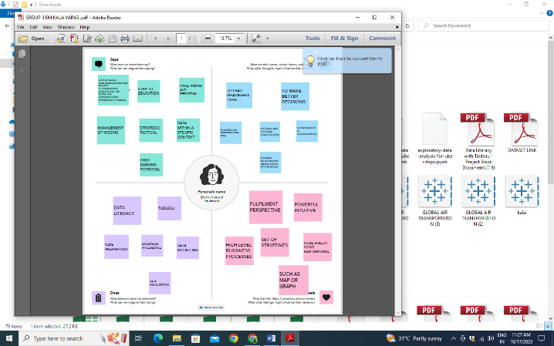

IDEATION & BRAINSTORMING MAP

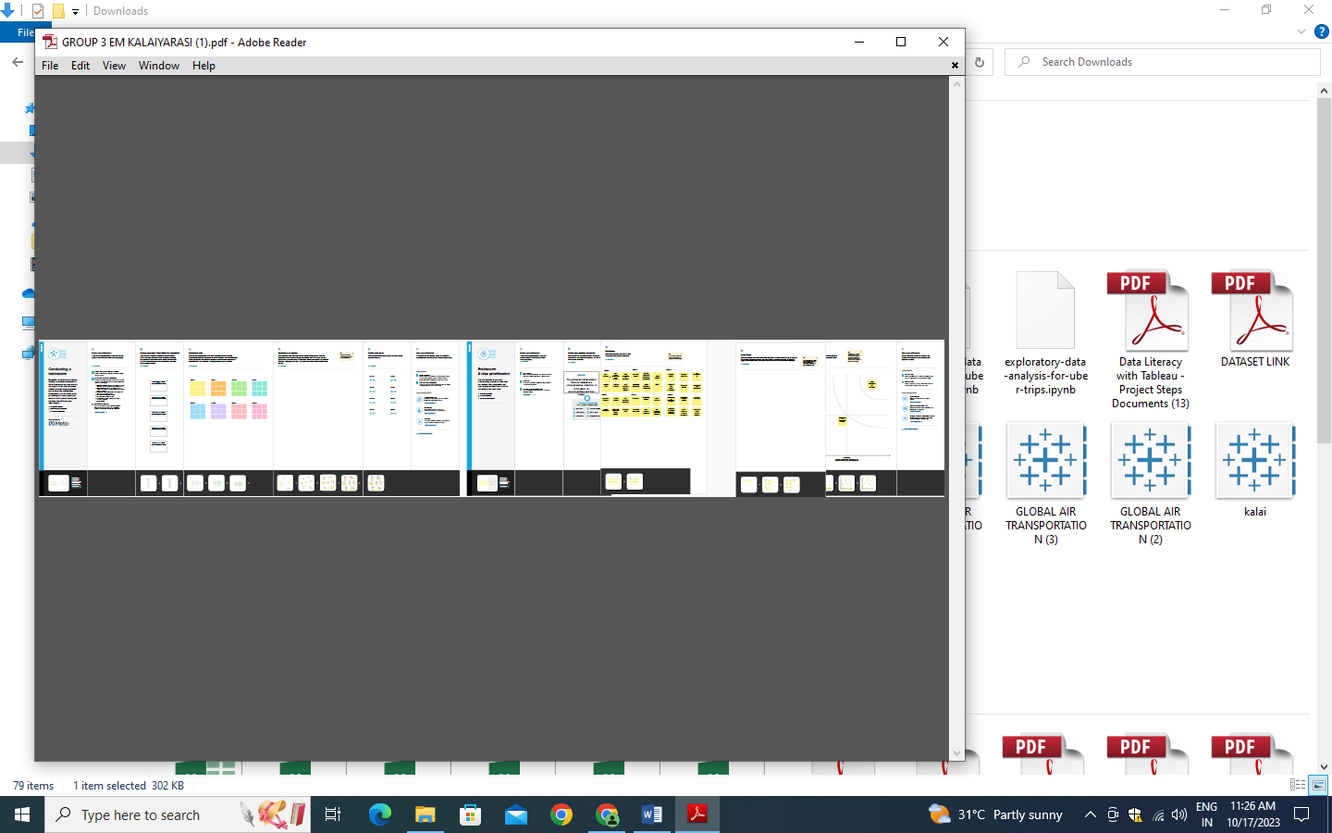

3.RESULT

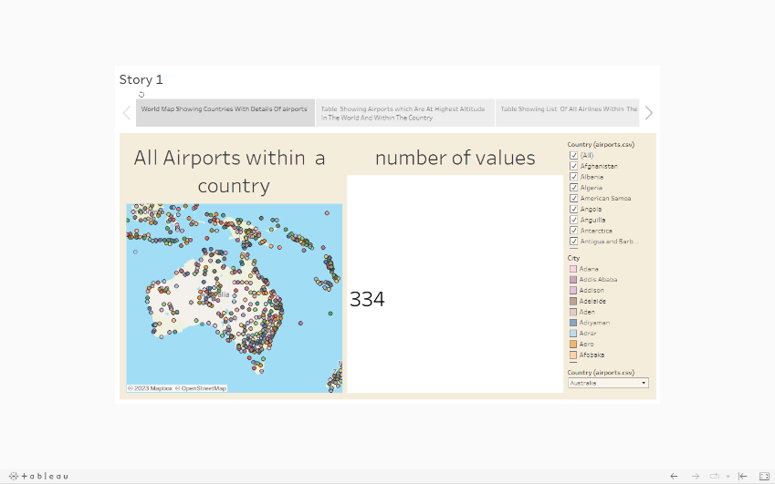

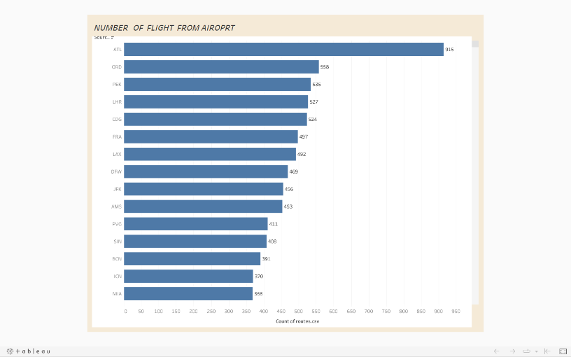

4.ADVANTAGES AND DISADVANTAGES

ADVANTAGES

* High speed air is the type of freight capable of travelling long distance in short periods of time.
* Send almost everywhere you freight.
* Speed. Affordableness safety comfortability.
* It allows people to travel quickly and conveniently, providing access to places that would otherwise be difficult to reach.

DISADVANTAGE

* Risky. air travel is the riskiest mode of transport, since there can be considerable losses to goods, customer and crews as a result of minor crash.
* Air transport can involve higher costs than other options, and is not suitable for all goods.
* Air transportation is a major contribute to air pollution.
* Air transport is prone to accidents as a small mistake can be very dangerous to passengers

5. APPLICATIONS

* Serves an extensive range of destination.
* Providing more connections between different destinations than would be possible with just direct flights.
* Aircraft are the fastest means of transportation and therefore the most suitable for shipping products within the supply chain that require fast and agile delivery.
* To market goods and products internationally or to deliver samples and documents related to foreign trade operations.
* Fresh air not only cleans your lungs, it can also boost your mood, lower your heart rate, increase energy levels and even improve digestion.

6. CONCLUSION

* International air transport is less than a century old, but is now a major contribute to globalization and is continually reshaping itself to meet the demands of the economic and social integration and globalization engenders.
* Economically, in static terms, globalization occurs to facilitate the greater division of labour and allows countries to exploit their comparative advantage more completely.

7. FUTUE SCOPE

* Emerging technologies are reshaping with robotics, artificial intelligence the internet of things, unnamed aircraft system and the push for hybrid and electric airplanes.
* Just to name a few. Alternative fuels can significantly change the current scenario of aviation in support of the environmental protection.
* The industry has a number of domestic and international airlines, as well as a large network of airport.